IAM TASK

1.Create one IAM user and assign EC2 and S3 full access roles.

Step 1: Open IAM
- Sign in to the AWS Console.
- Search for IAM in the search bar.
- Open IAM Dashboard.
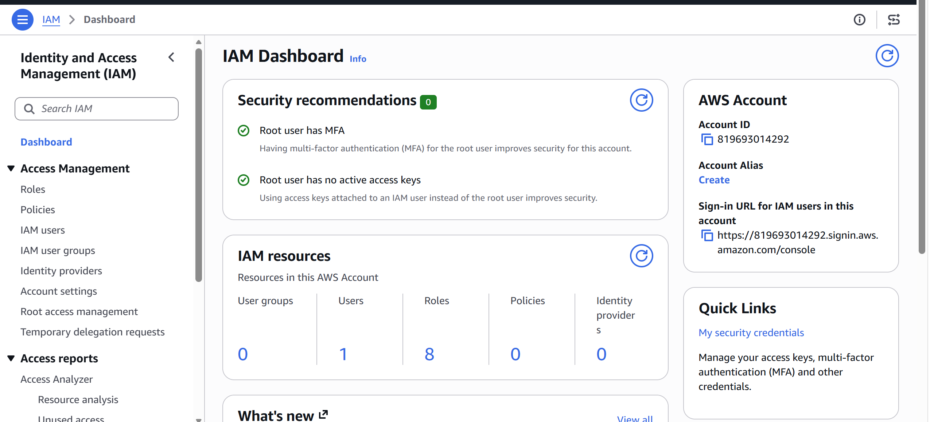

Step 2: Create an IAM User
- In the left menu, click Users.
- Click Create user.
- Enter a username.
Example:
ec2s3user
- Click Next.
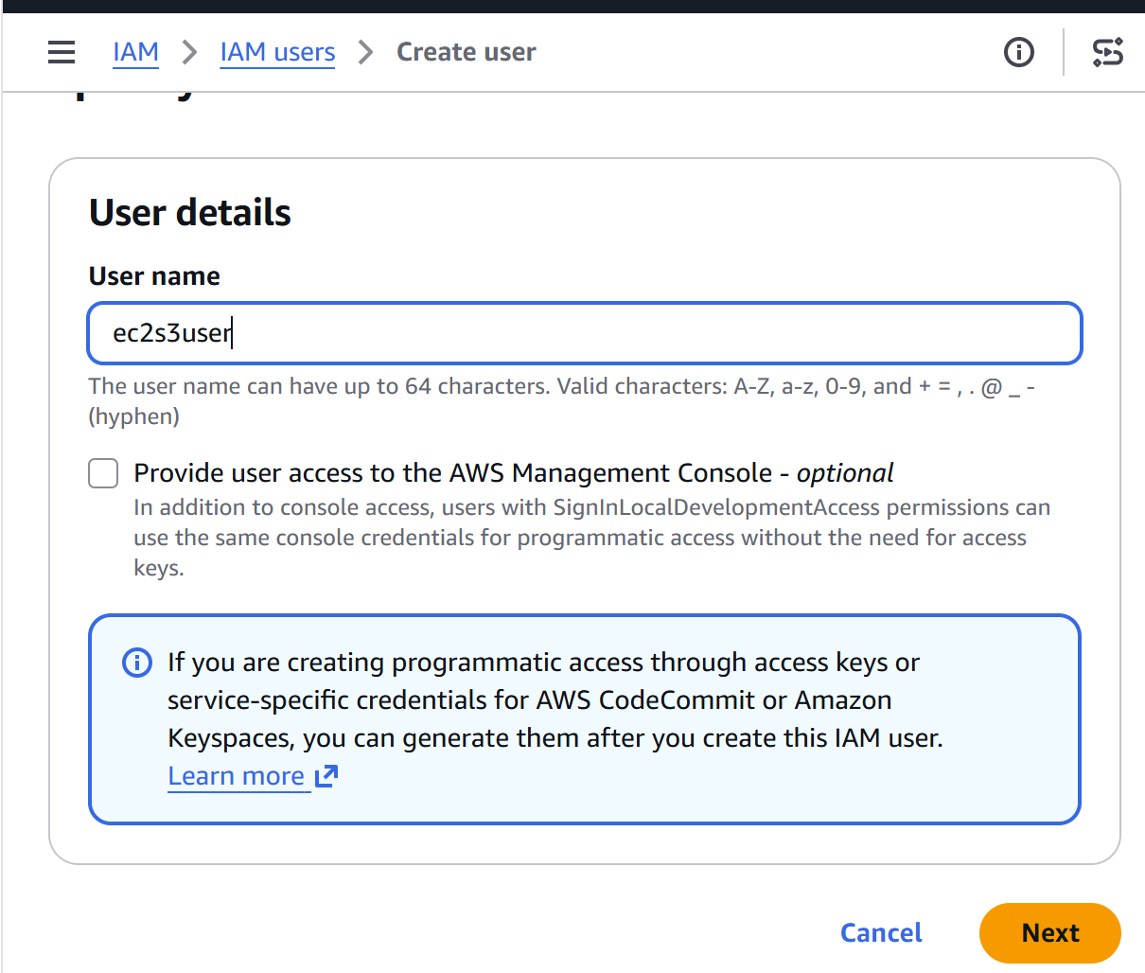

Step 3: Set Permissions
Choose
Attach policies directly
This allows you to attach AWS managed policies.
Click Next.
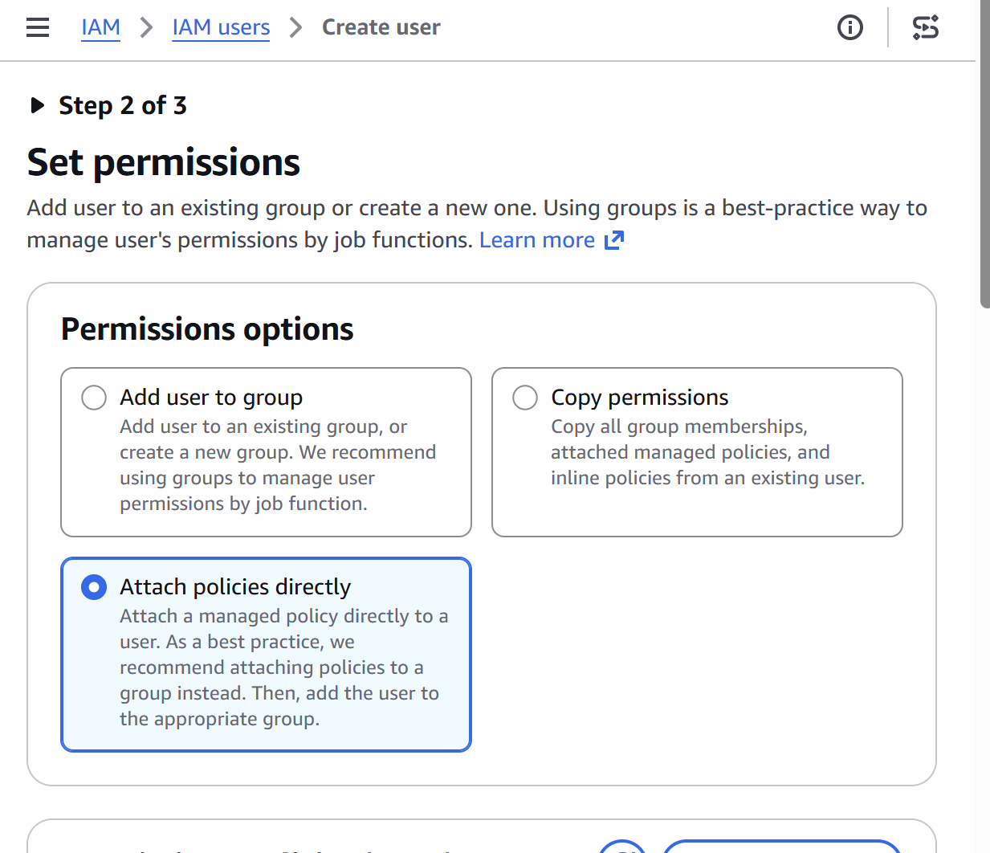

Step 4: Attach EC2 Full Access Policy
In the search box type
EC2
Select
AmazonEC2FullAccess
✔ Check the box.
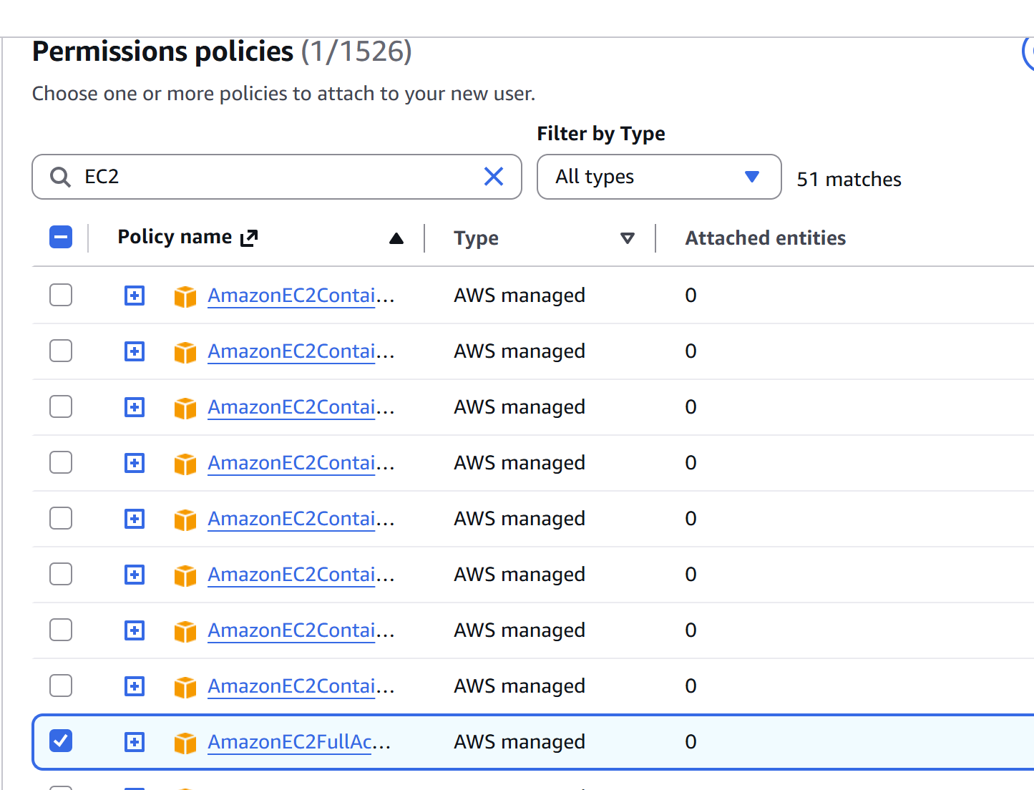

Step 5: Attach S3 Full Access Policy
In the search box type
S3
Select
AmazonS3FullAccess
✔ Check the box.
You should now have these two policies selected:
- ✅ AmazonEC2FullAccess
- ✅ AmazonS3FullAccess
Click Next.
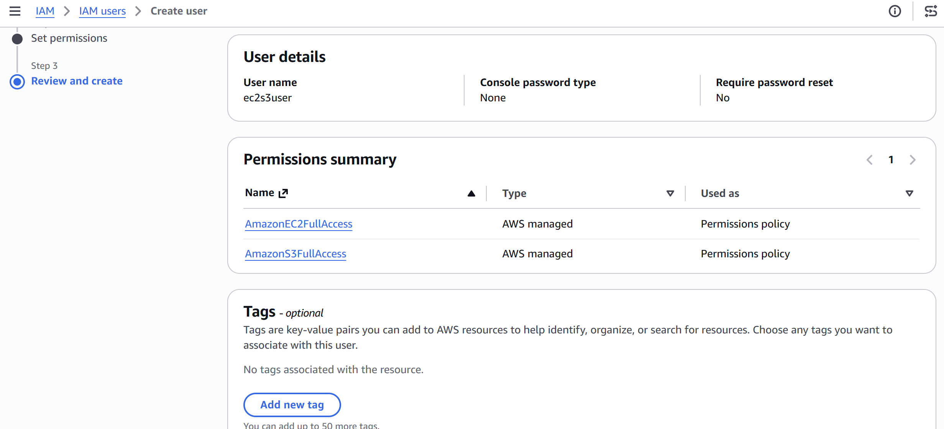

Step 6: Review
Verify:
- Username: ec2s3user
- Policies:
  - AmazonEC2FullAccess
  - AmazonS3FullAccess
Click Create user.
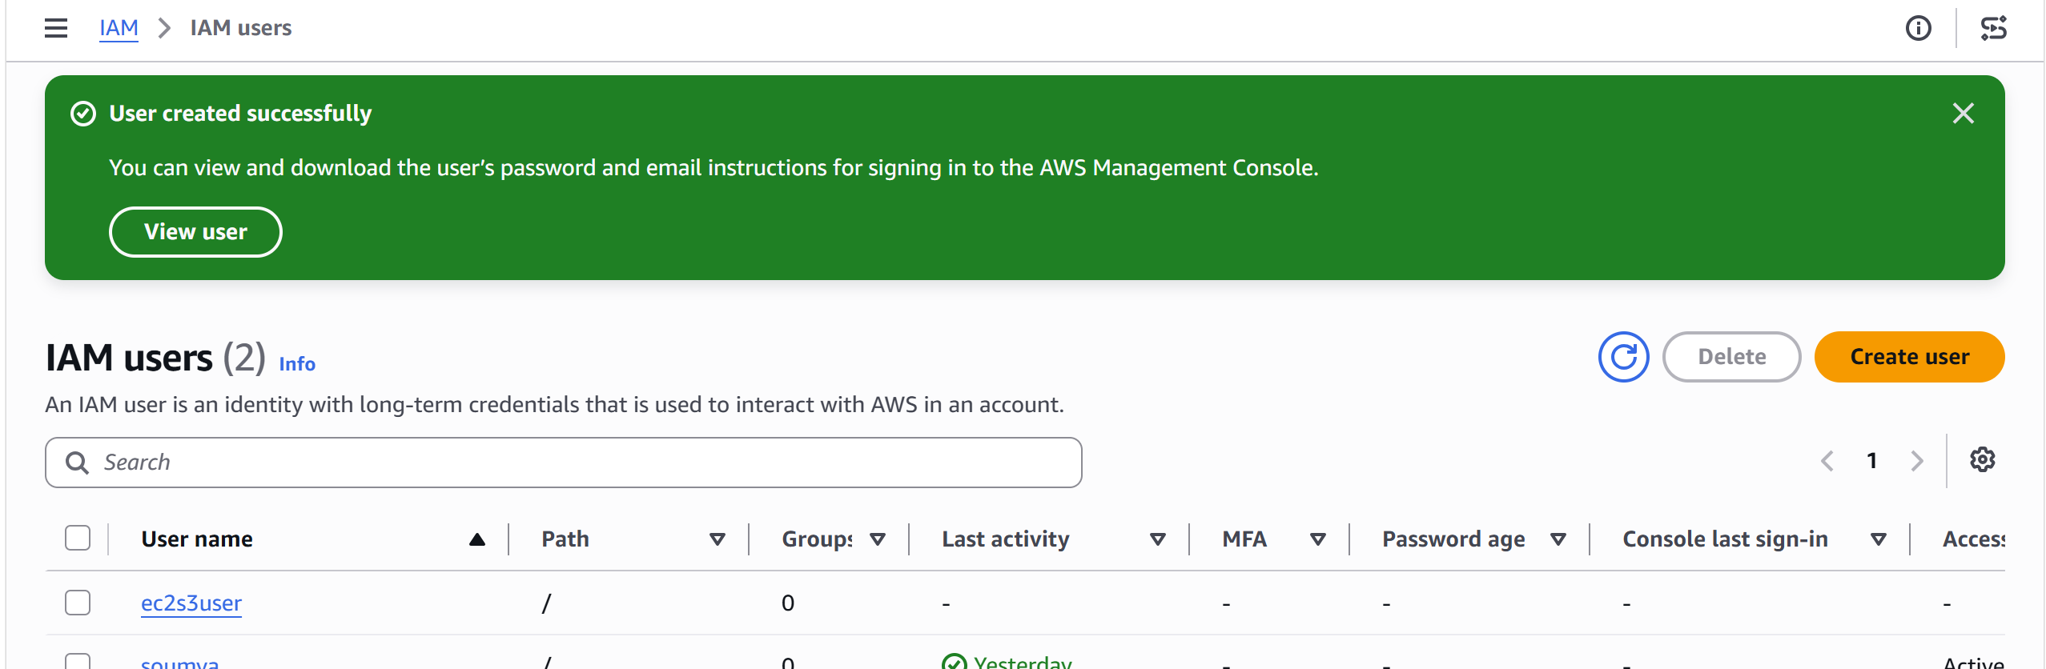
Step 7: Verify Permissions
- Open IAM → Users.
- Click on ec2s3user.
- Open the Permissions tab.
You should see:
AmazonEC2FullAccess
AmazonS3FullAccess

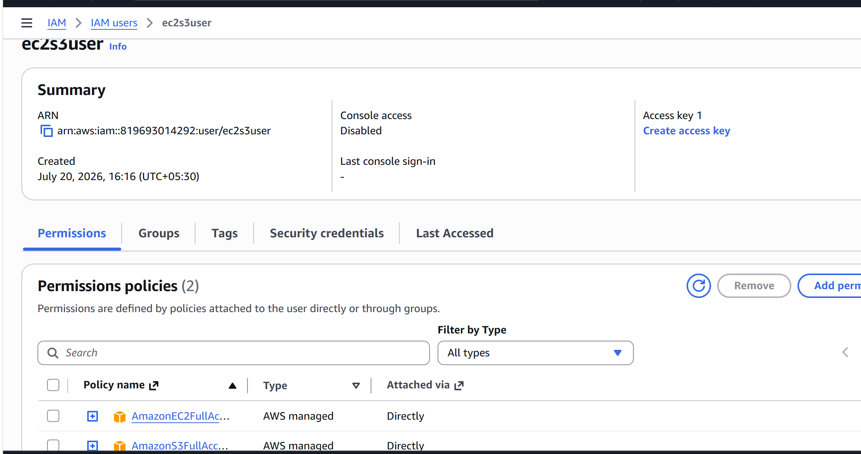
Step 8: Create Access Keys
- Open the ec2s3user user.
- Select the Security credentials tab.
- Scroll to Access keys.
- Click Create access key.
- Choose Command Line Interface (CLI).
- Acknowledge the recommendation.
- Click Next.
- Click Create access key.
You'll receive:
Access Key ID:
AKIA....................

Secret Access Key:
xxxxxxxxxxxxxxxxxxxxxxxx
Save these values because the secret key is shown only once.

Step 9: Configure the AWS CLI
On your terminal, run:
aws configure
Enter:
AWS Access Key ID [None]: AKIAxxxxxxxxxxxxxxxx
AWS Secret Access Key [None]: xxxxxxxxxxxxxxxxxxxxx
Default region name [None]: us-east-1
Default output format [None]: json

Step 10: Verify the CLI Is Using ec2s3user
Run:
aws sts get-caller-identity
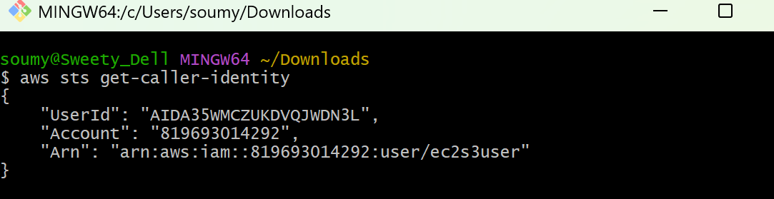
Step 11: Verify EC2 Access
List EC2 instances:
aws ec2 describe-instances
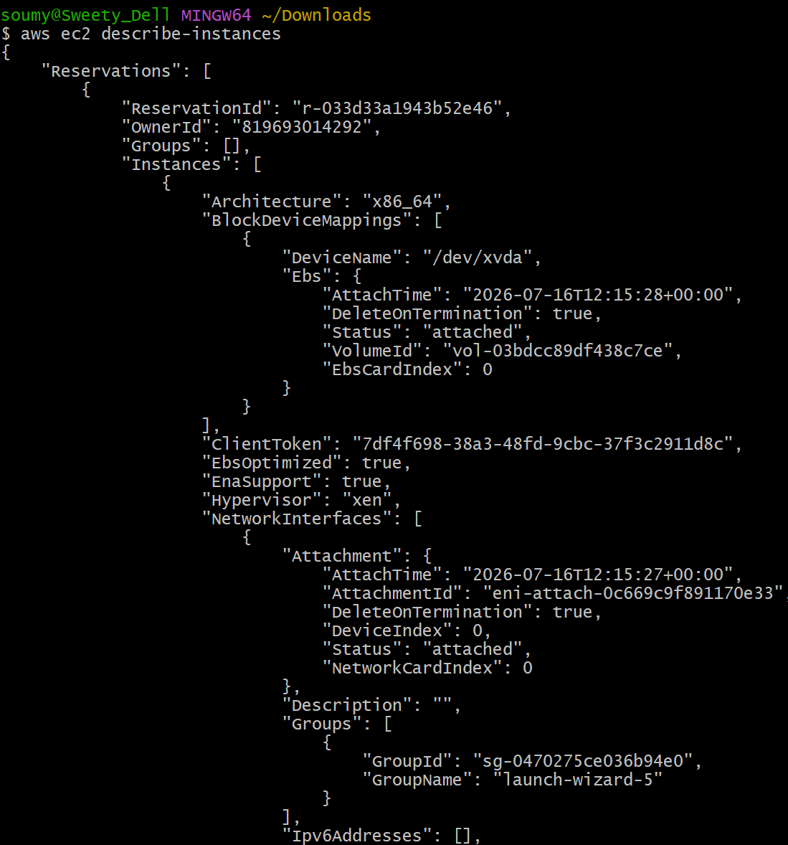
Step 12: Verify S3 Access
List S3 buckets:
aws s3 ls
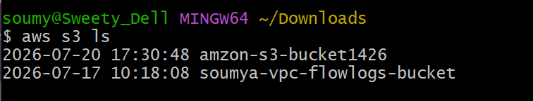

2. Create one group in IAM and assign read access for EC2.

Step 1: Open IAM
- Sign in to the AWS Management Console.
- Search for IAM.
- Open the IAM service.

Step 2: Create a Group
- In the left navigation pane, click User groups.
- Click Create group.
- Enter a group name.
Example:
EC2ReadOnlyGroup
- Click Next (or continue to the permissions page).
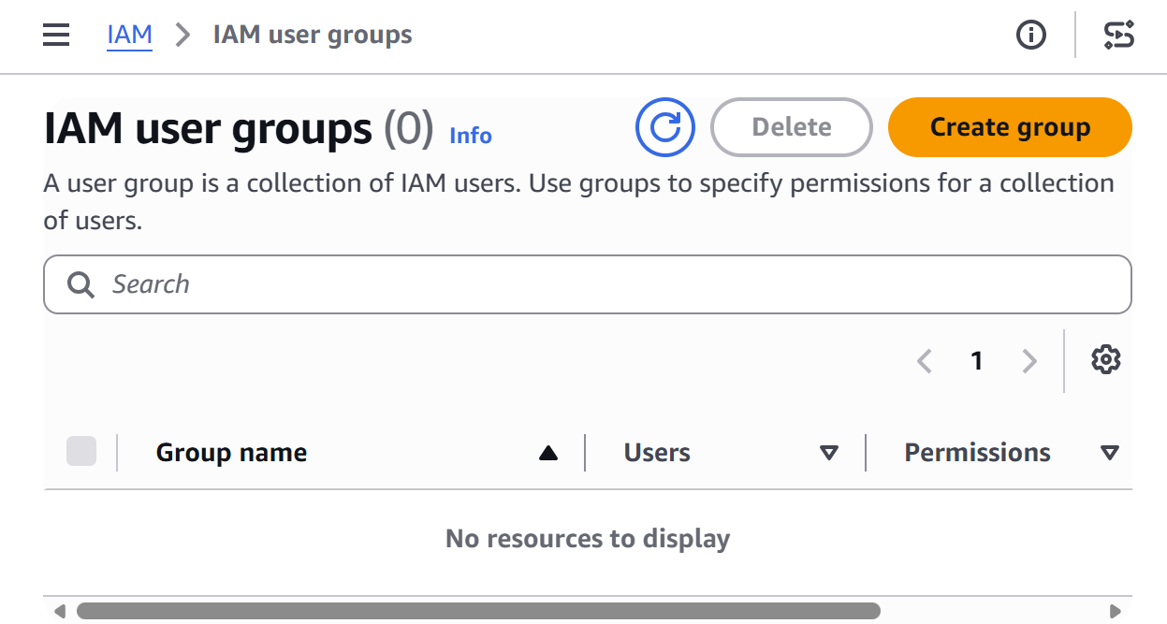
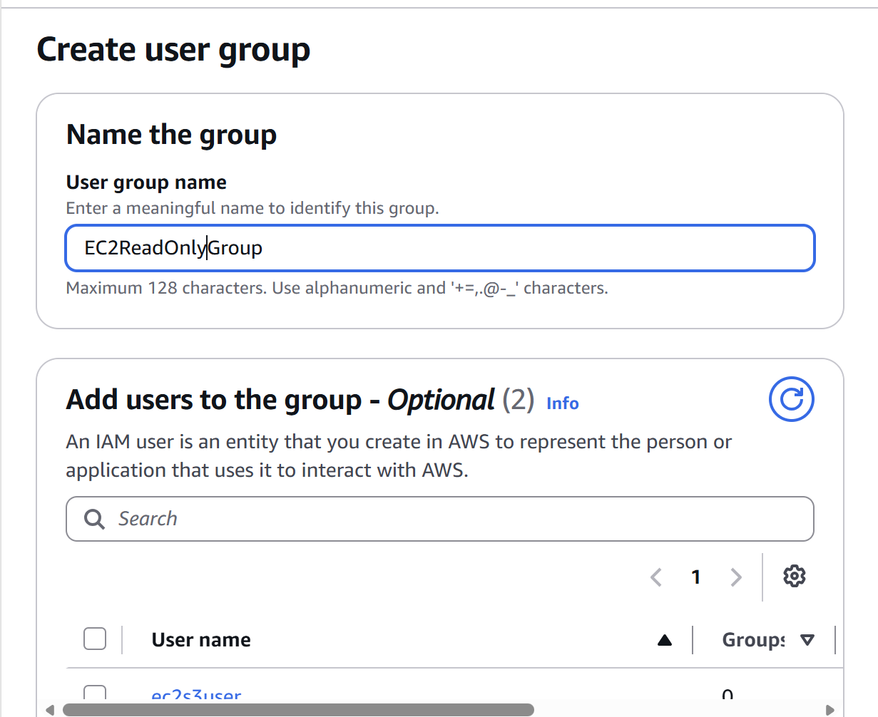

Step 3: Assign EC2 Read-Only Permission
- In the Attach permissions policies section, search for:
AmazonEC2ReadOnlyAccess
- Select the checkbox next to:
AmazonEC2ReadOnlyAccess
This AWS managed policy allows users to view EC2 resources but does not allow creating, modifying, or deleting them.
- Click Next.
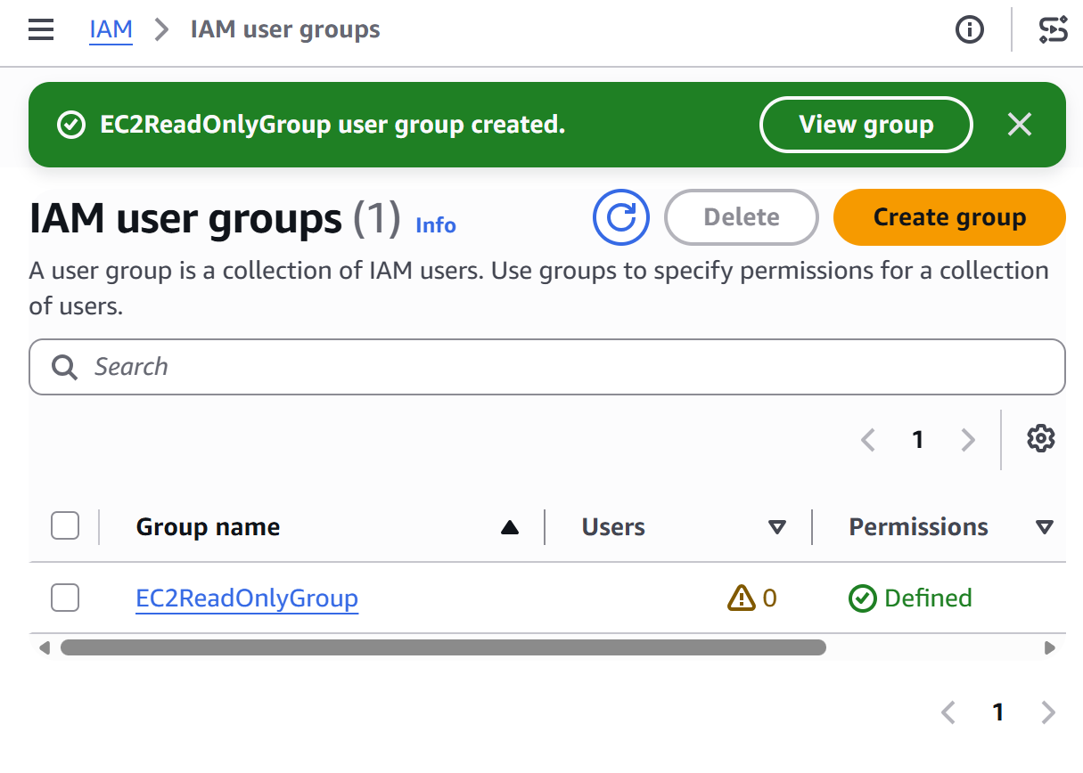

Step 4: Review and Create
Verify:
- Group Name: EC2ReadOnlyGroup
- Policy Attached: AmazonEC2ReadOnlyAccess
Click Create group.

Step 5: Verify the Group
- Go to IAM → User groups.
- Click EC2ReadOnlyGroup.
- Open the Permissions tab.
You should see:
AmazonEC2ReadOnlyAccess
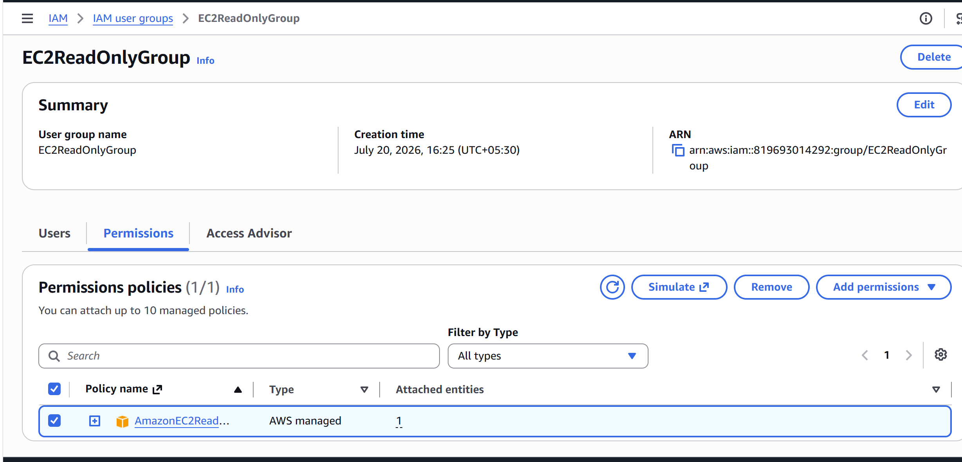
3. Create a new user named "Devops" and add to the group created in task 2.

Step 1: Open IAM
- Sign in to the AWS Management Console.
- Search for IAM.
- Open the IAM service.
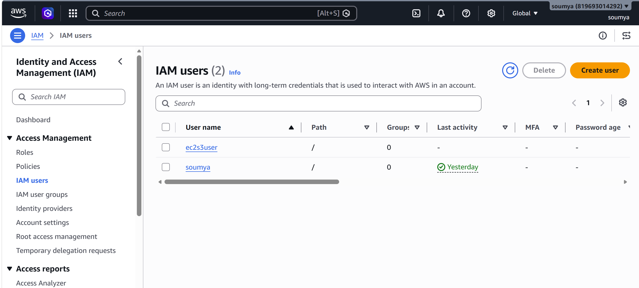

Step 2: Create the User
- In the left navigation pane, click Users.
- Click Create user.
- Enter the user name:
Devops
- Click Next.
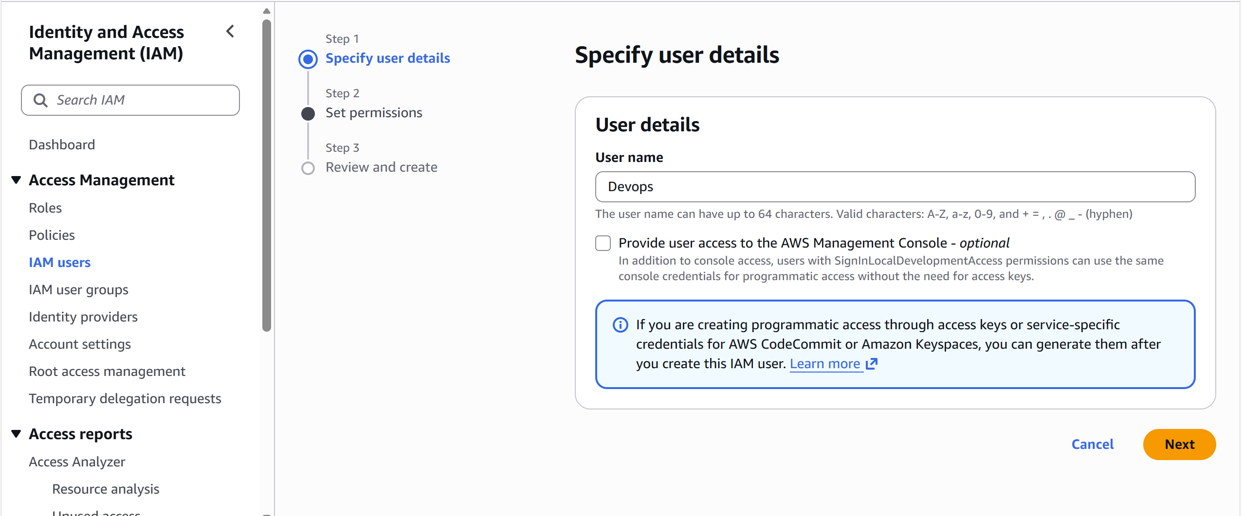

Step 3: Add the User to the Existing Group
- Choose:
Add user to group
- From the list of groups, select the group you created in Task 2.
Example:
EC2ReadOnlyGroup
- Check the box next to the group.
- Click Next.
Since the group already has the AmazonEC2ReadOnlyAccess policy attached, the Devops user will automatically inherit those permissions.

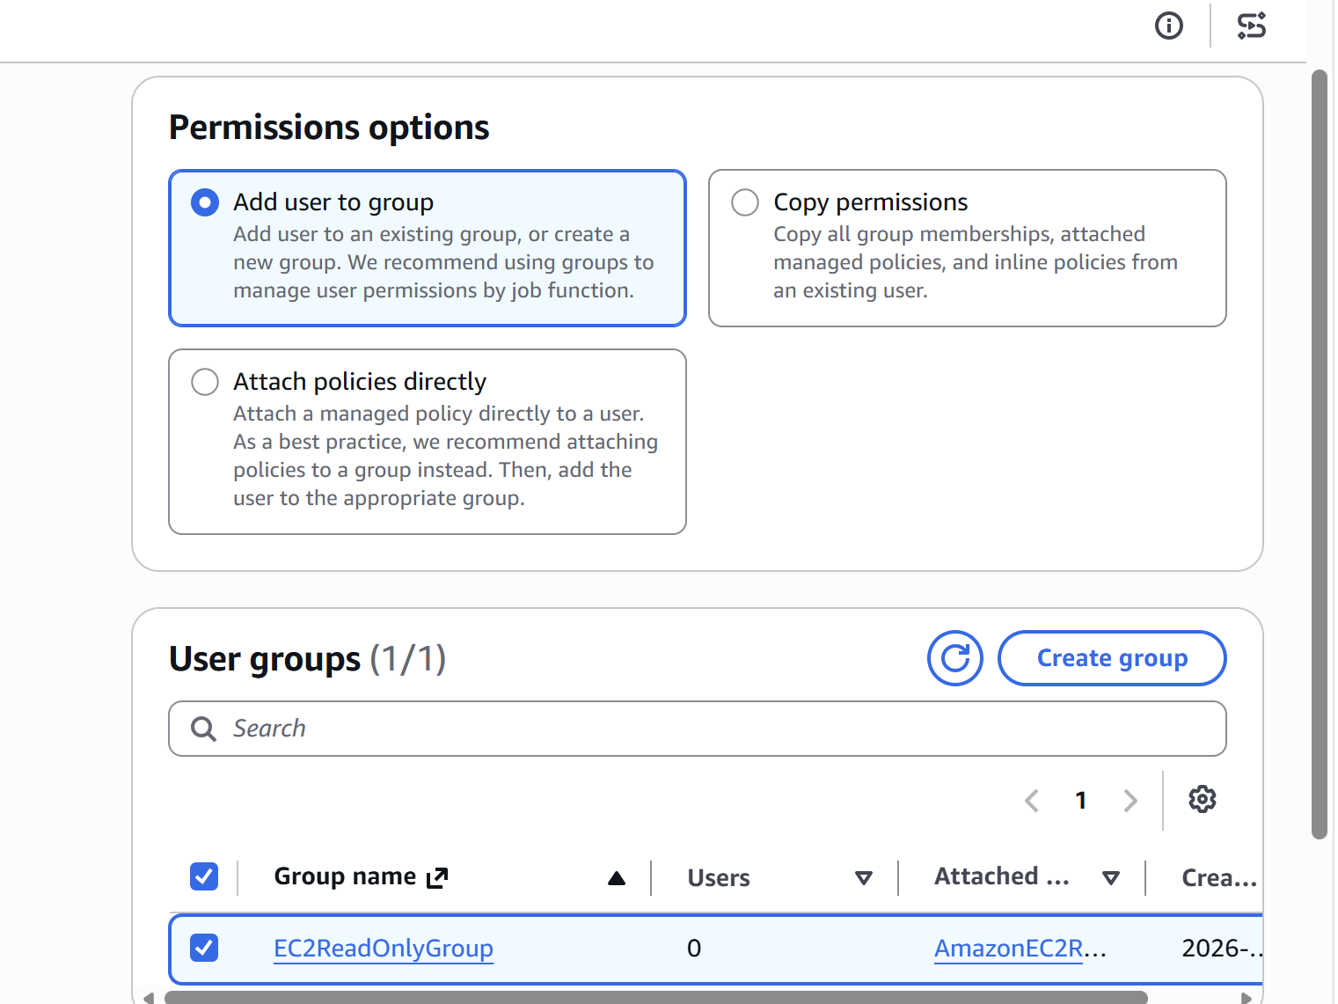
Step 4: Review
Verify the details:
Click Create user.
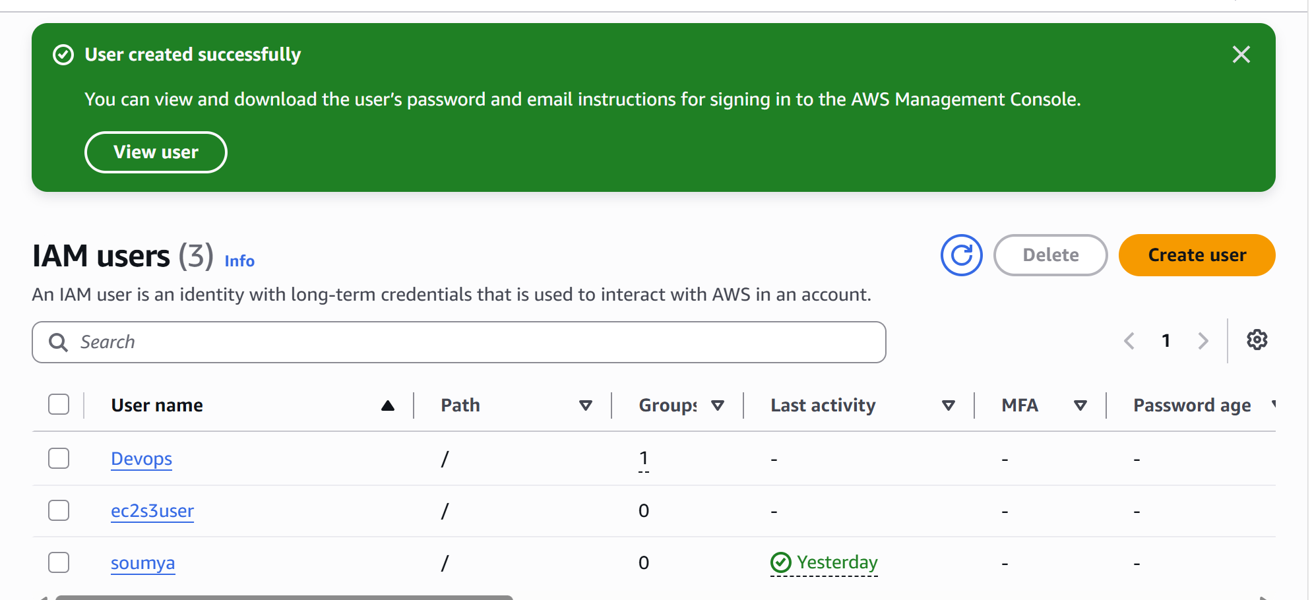
Step 5: Verify
- Go to IAM → Users.
- Click Devops.
- Open the Groups tab.
You should see:
EC2ReadOnlyGroup
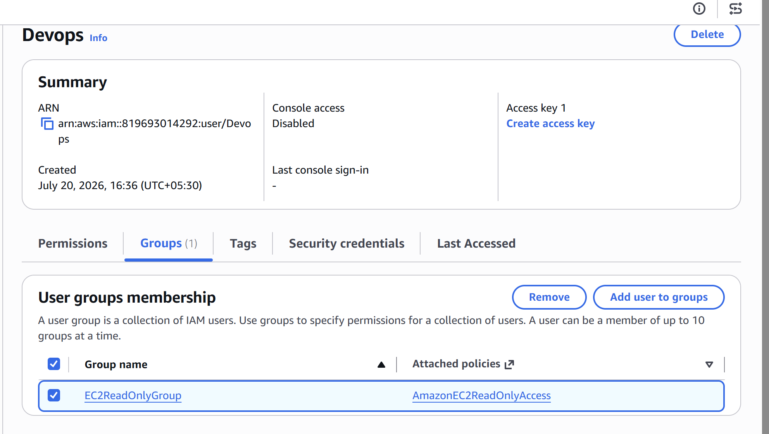
- Open the Permissions tab to confirm that the user has inherited:
AmazonEC2ReadOnlyAccess

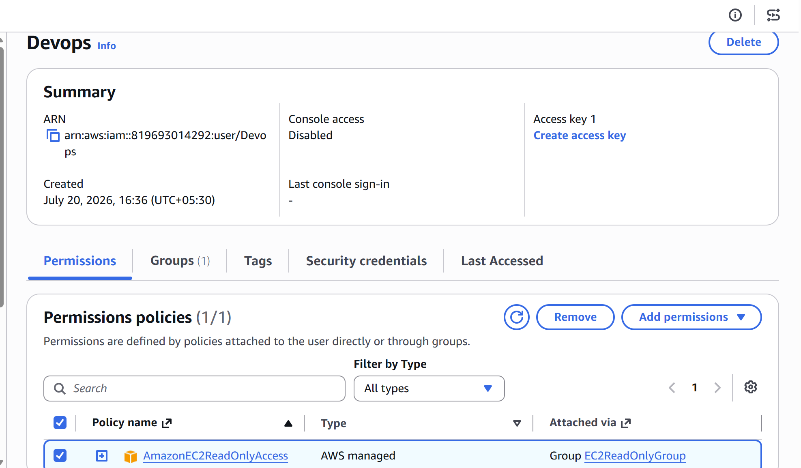
4. Write a bash script to create an IAM user with VPC full access.
You can use the AWS CLI to create an IAM user and attach the AmazonVPCFullAccess managed policy.
Prerequisites
- AWS CLI is installed.
- AWS CLI is configured (aws configure).
- The IAM identity running the script has permission to create IAM users and attach policies.
Bash Script (create_iam_user.sh)
Vi create_iam_user.sh
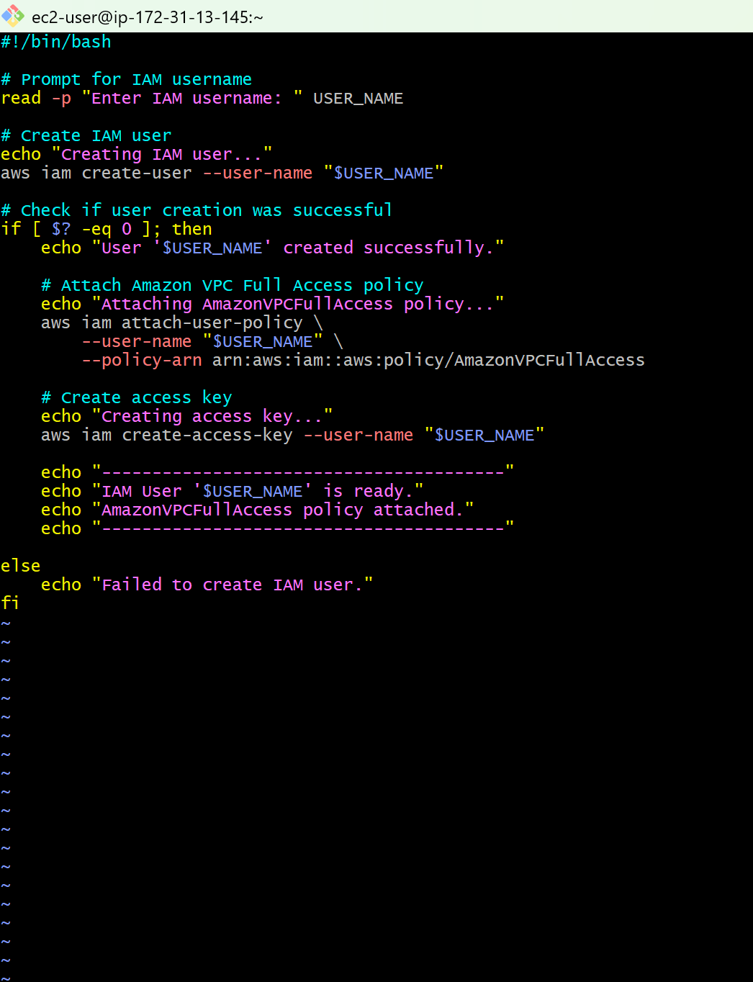
Output:
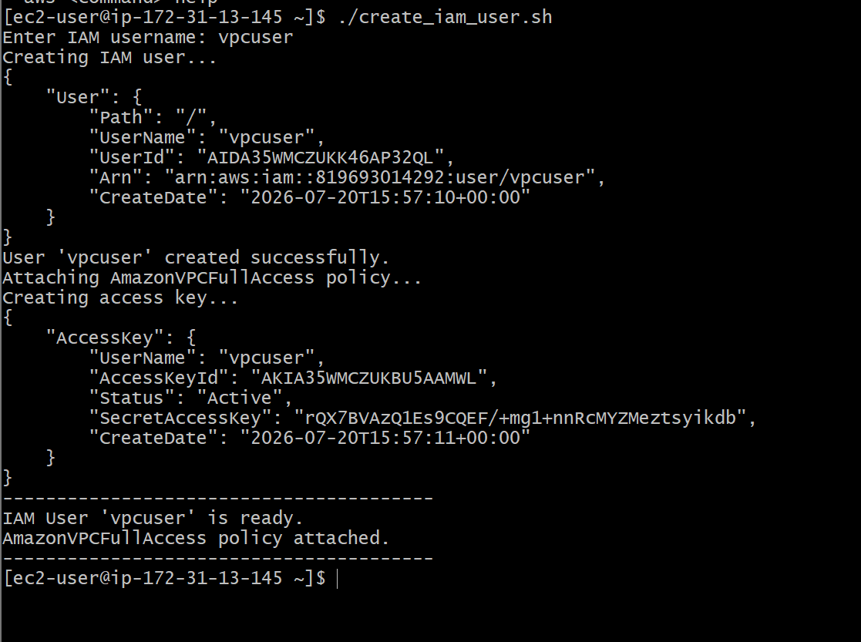

Verification Through AWS CLI
1. Verify the user exists
aws iam get-user --user-name vpcuser
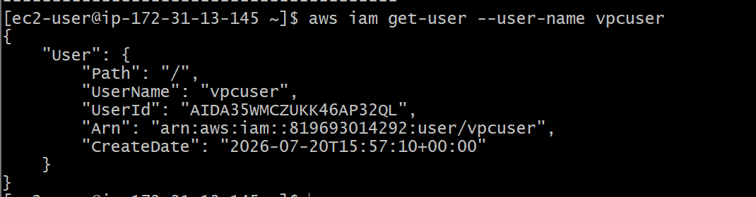
2. Verify the attached policy
aws iam list-attached-user-policies --user-name vpcuser
Expected output:
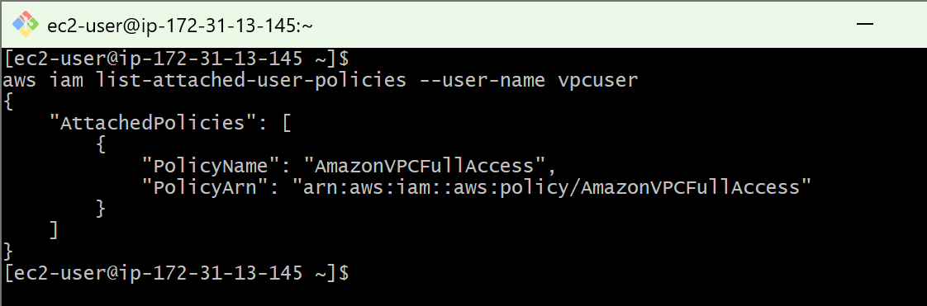
3. Verify the access keys
aws iam list-access-keys --user-name vpcuser
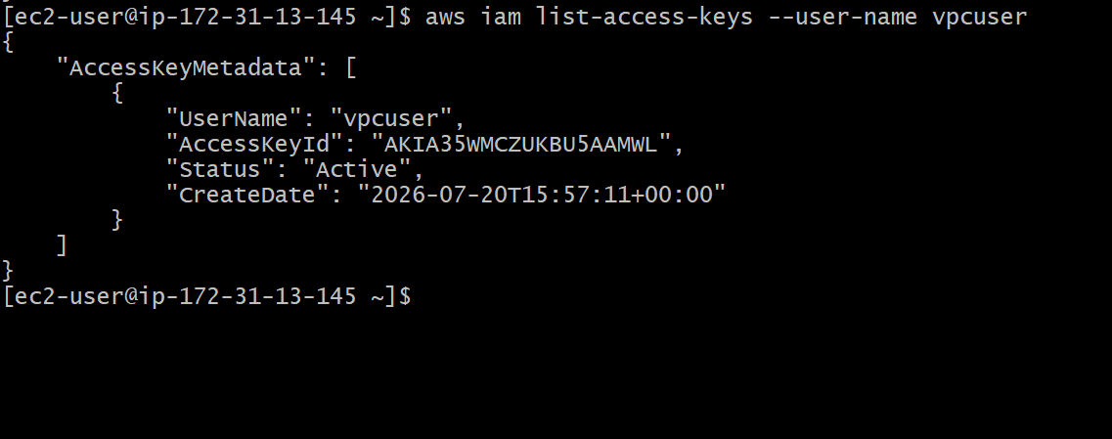

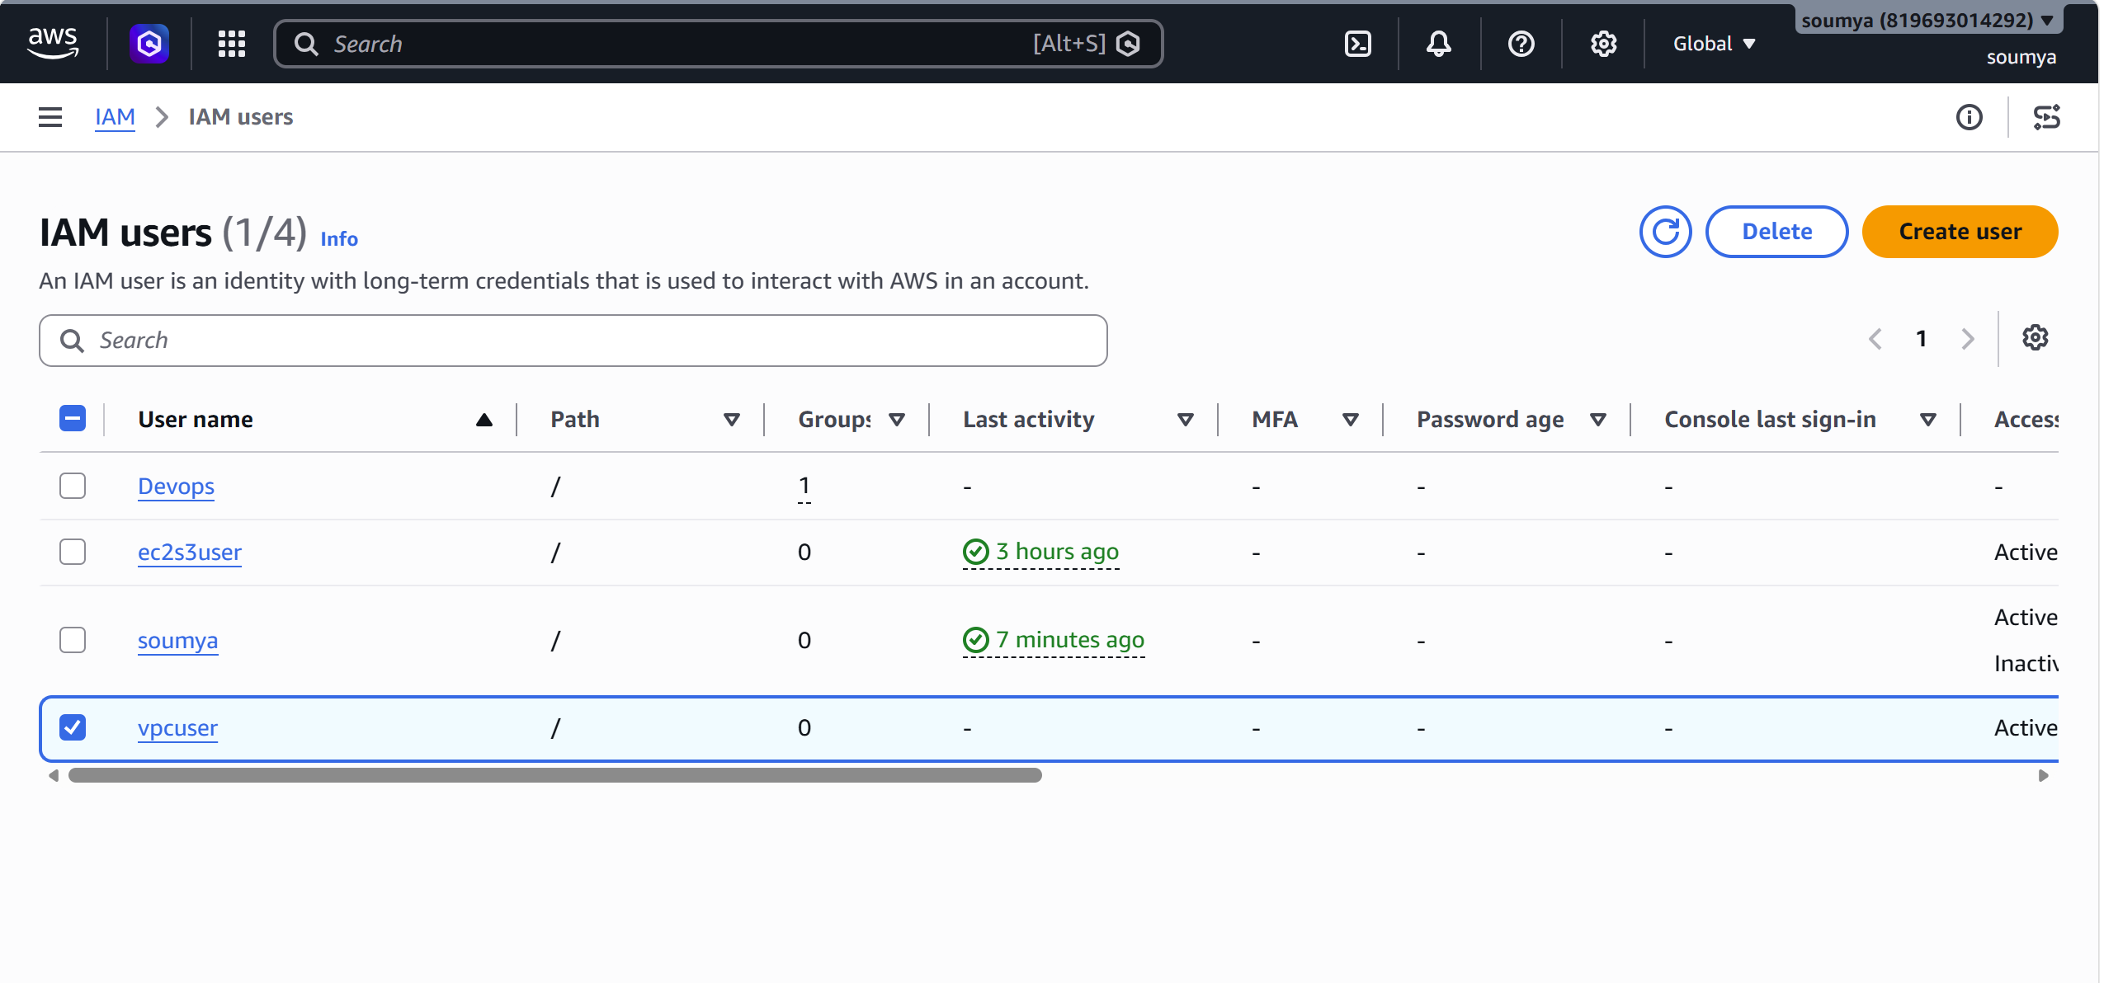
5. Create an IAM policy to allow EC2 access for a specific user in specific regions only.
Step 1: Log in to AWS
Open the AWS Management Console.
Search for:
IAM
Open IAM.

Step 2: Create an IAM User
- Click Users
- Click Create user
User name:
ec2-region-user
Click Next.
Choose:
- ✔ Provide user access to the AWS Management Console (optional if console access is needed)
Finish creating the user.
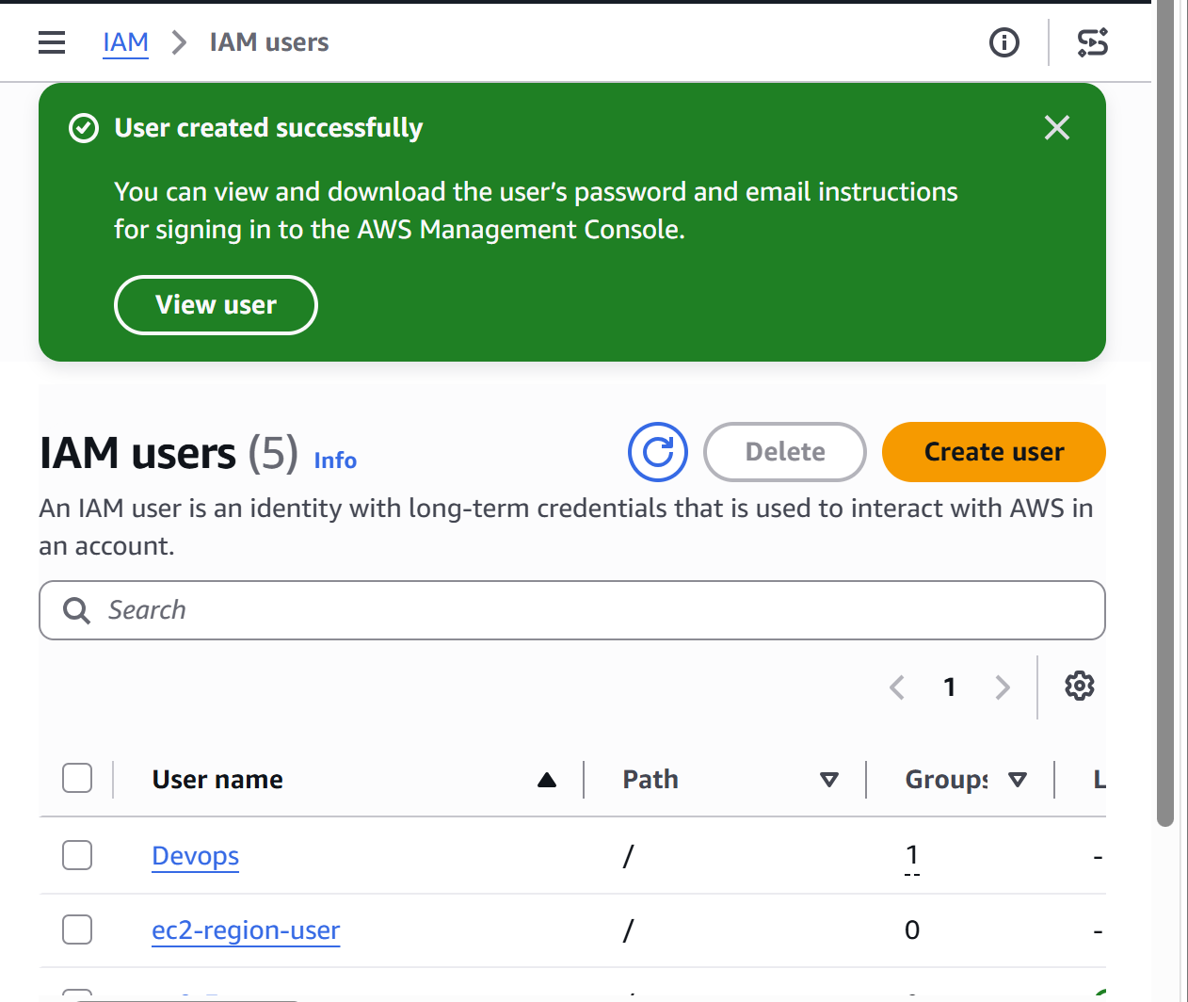
Step 3: Create a Custom IAM Policy
Go to:
IAM → Policies
Click:
Create policy
Choose the JSON tab.
Delete the existing content.
Paste the following policy:
{
"Version": "2012-10-17",
"Statement": [
{
"Sid": "AllowEC2OnlyInSpecificRegions",
"Effect": "Allow",
"Action": "ec2:*",
"Resource": "*",
"Condition": {
"StringEquals": {
"aws:RequestedRegion": [
"us-east-1",
"ap-south-1"
]
}
}
}
]
}
Click Next.
Policy name:
EC2-Specific-Regions
Description:
Allow EC2 access only in us-east-1 and ap-south-1
Click:
Create policy
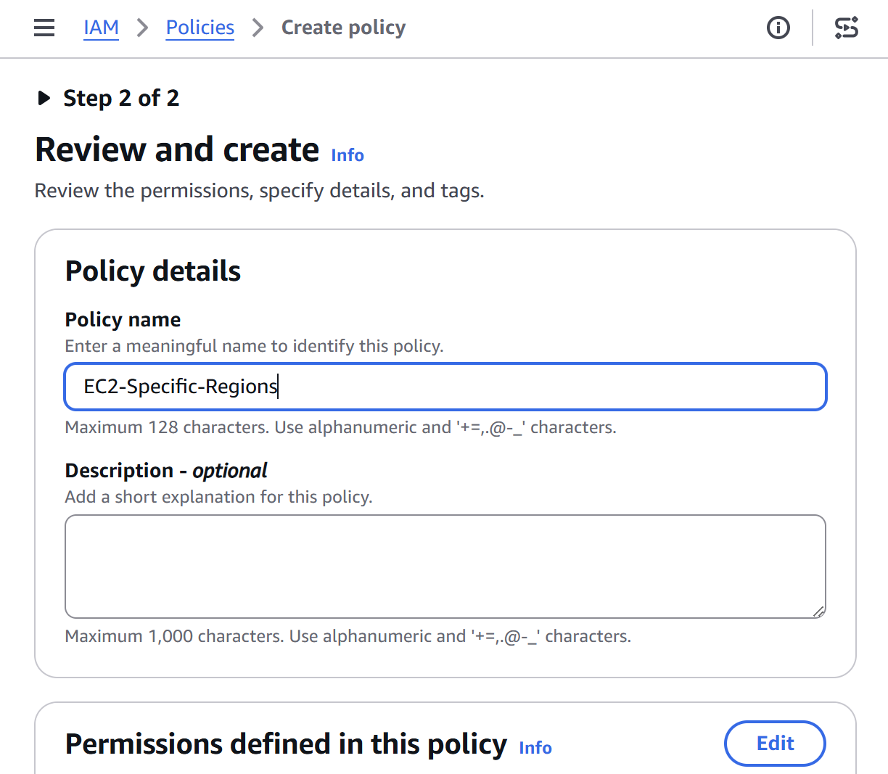
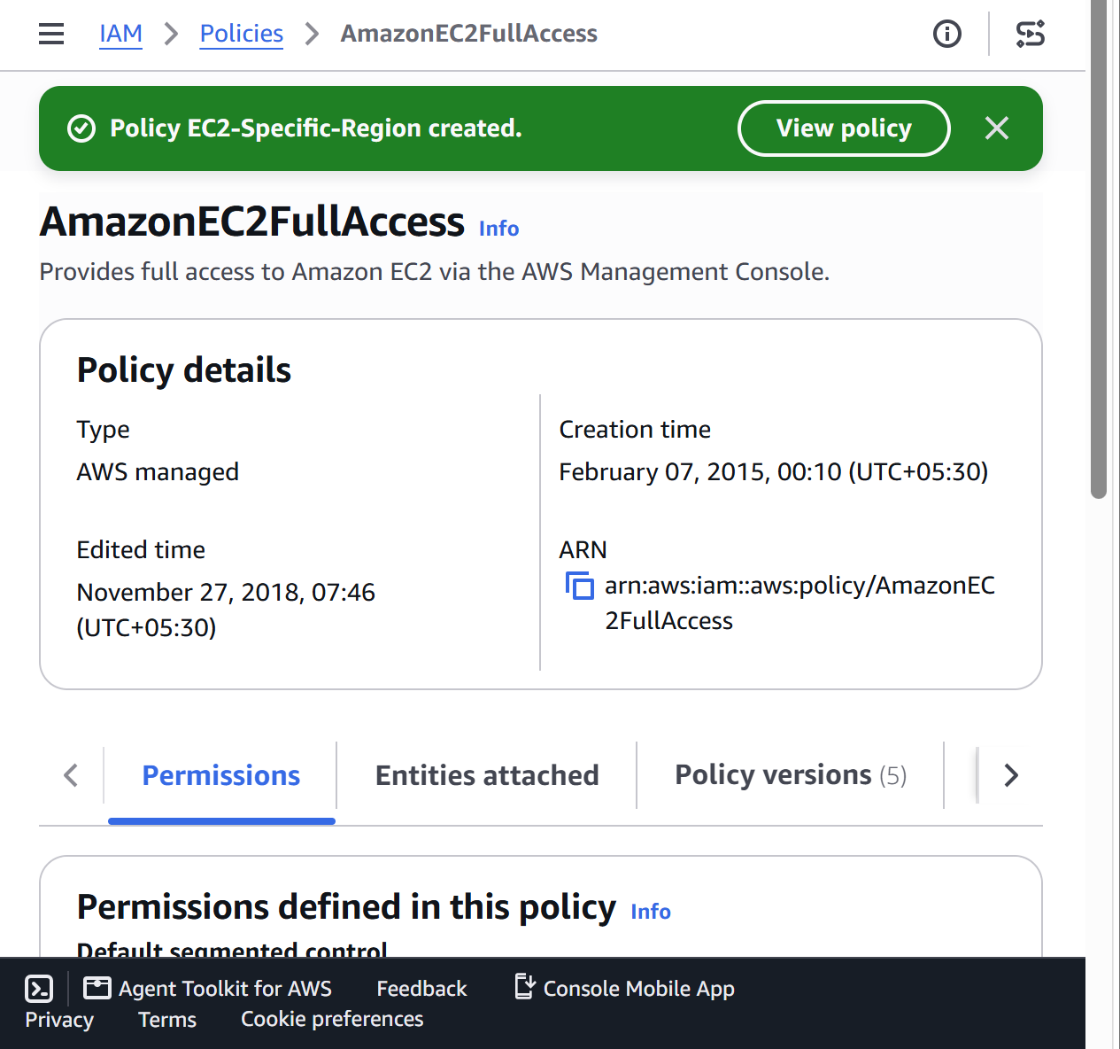
Step 4: Attach the Policy to the User
Go to:
IAM → Users
Select:
ec2-region-user
Open the Permissions tab.
Click:
Add permissions
Choose:
Attach policies directly
Search for:
EC2-Specific-Regions
Select it.
Click:
Next
Click:
Add permissions
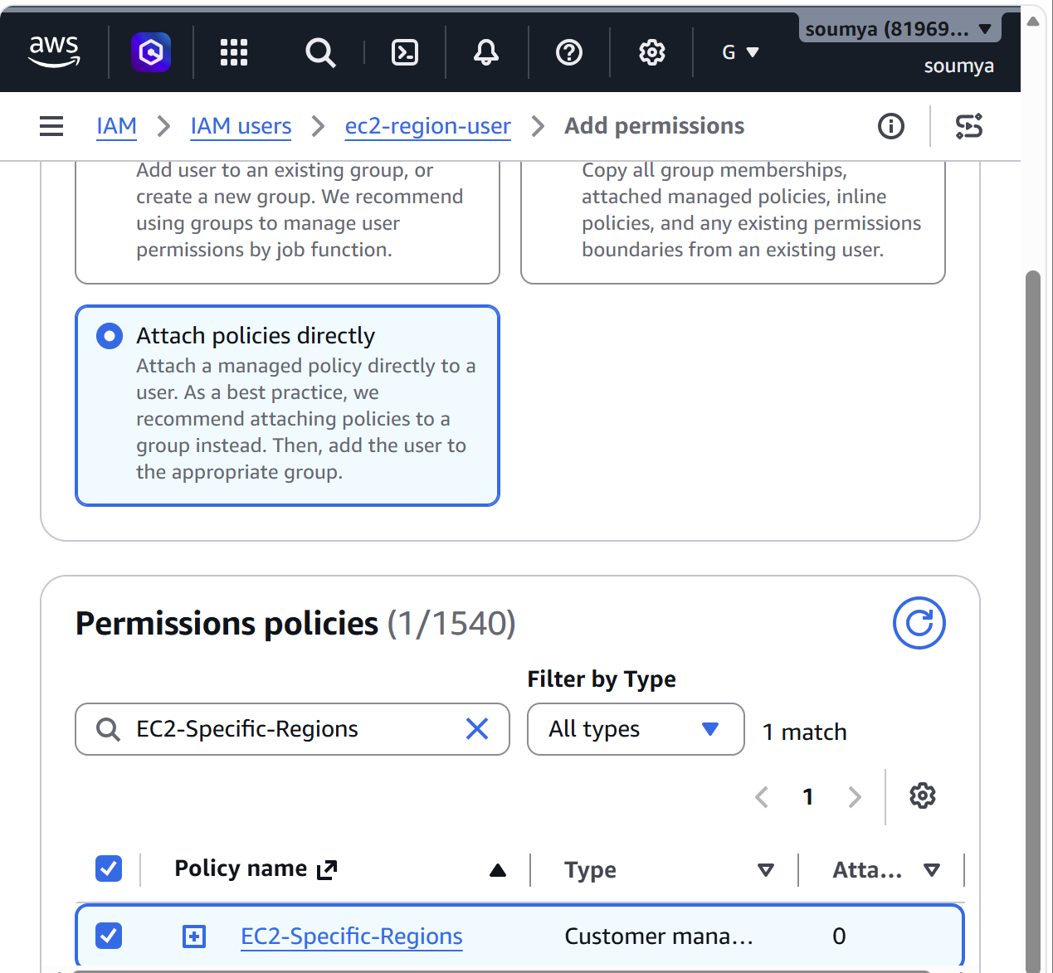

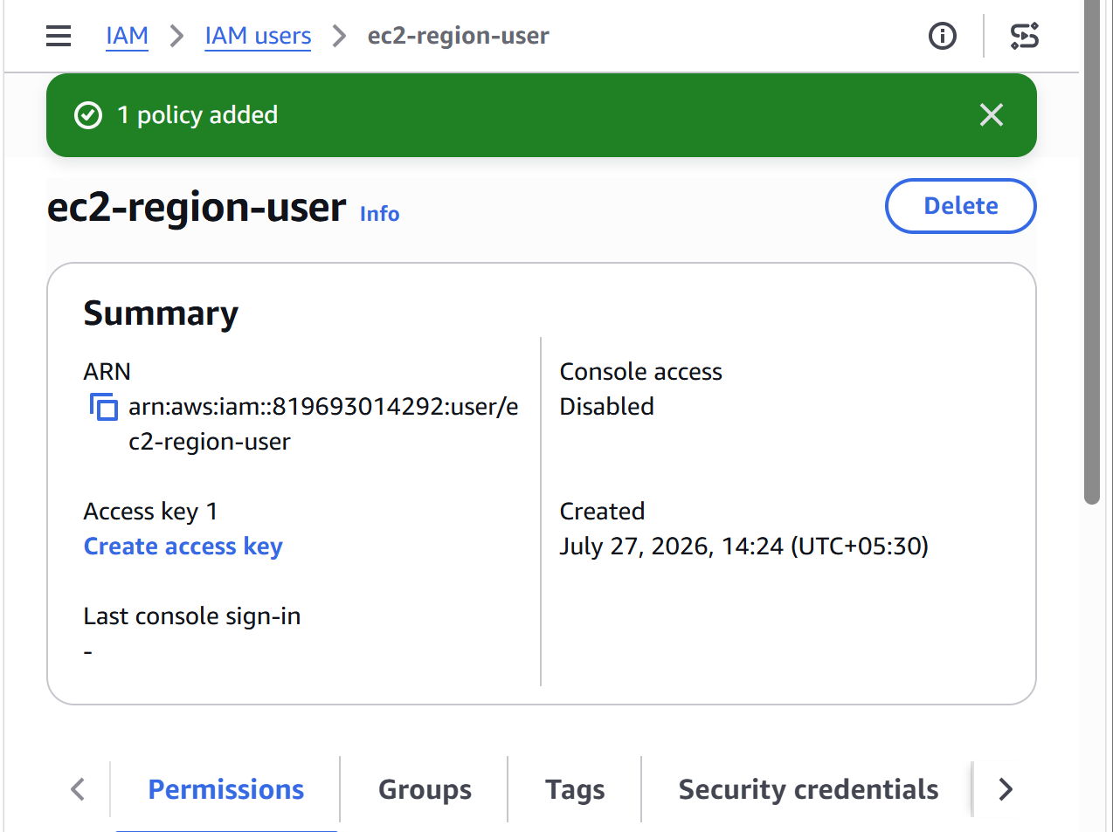
Step 5: Test the Policy
Allowed Region
Switch the AWS Console to:
US East (N. Virginia)
or
Asia Pacific (Mumbai)
You should be able to:
- View EC2 instances
- Launch EC2 instances
- Stop/start instances
- Manage EC2 resources

